Name***:***

* Ahmed MohamedBadr
* Mohamed Ibrahem Soliman

Group***:*** SE2

App name*:*Online Bank

Reference:

https://github.com/SabaUrgup/online-BankApp

**public class BankaHesabi {**

**private int iban;**

**private double bakiye;**

**public String toString() {**

**return super.toString()+ "BankaHesabi{" + "\t iban=" + iban + ",\t bakiye=" + bakiye + '}';**

**}**

**public double getIban() {**

**return this.iban;**

**}**

**public double getBakiye() {**

**return bakiye;**

**}**

**public void setBakiye(double bakiye) {**

**this.bakiye = bakiye;**

**}**

**public BankaHesabi(double bakiye) {**

**this.bakiye = bakiye;**

**Random random = new Random();**

**this.iban = random.nextInt(100000) + 10000;**

**}**

**}**

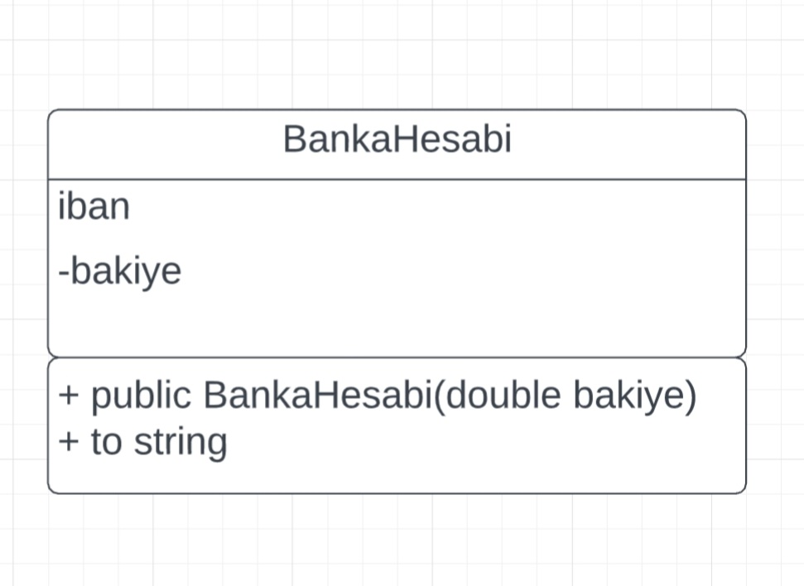

**public class BankaPersoneli extends Kisi{**

**private long personalID;**

**private ArrayList<Musteri> Musteriler= new ArrayList<Musteri>();;**

**public BankaPersoneli(String ad, String soyad, String email, long telefonNumarasi) {**

**super(ad, soyad, email, telefonNumarasi);**

**Random rand= new Random(); this.personalID=rand.nextInt(100000)+100;**

**} public void setMusteriler(ArrayList<Musteri> Musteriler) {**

**this.Musteriler = Musteriler;**

**}**

**public ArrayList<Musteri> getMusteriler()**

**{**

**return Musteriler;**

**}**

**public void musteriEkle(Musteri musteriNumarasi){**

**Musteriler.add(musteriNumarasi);**

**System.out.println("Musteri eklendi!");**

**}**

**public void musteriSil(Musteri musteriNumarasi){**

**Musteriler.remove(musteriNumarasi);**

**System.out.println("Musteri silindi!");**

**}**

**public long getPersonelID(){**

**return personalID;**

**}**

**@Override**

**public String toString() {**

**return "BankaPersoneli{" + "\n personalID=" + personalID +"\nMusteriler: "+this.getMusteriler()+ '}';**

**}**

**}**

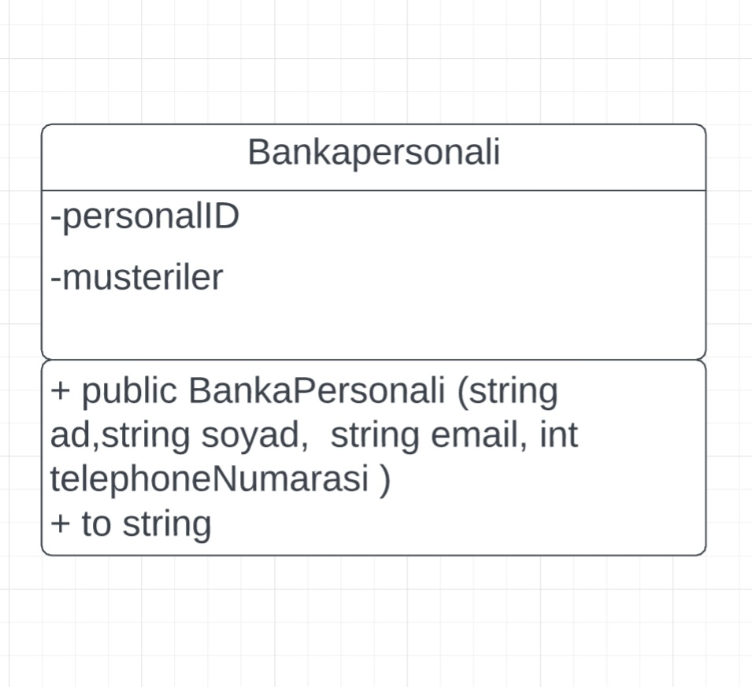

**public class Kisi {**

**private String ad, soyad, email;**

**private long telefonNumarasi;**

**public Kisi(String ad, String soyad, String email, long telefonNumarasi) {**

**this.ad = ad;**

**this.soyad = soyad;**

**this.email = email;**

**this.telefonNumarasi = telefonNumarasi;**

**}**

**public String getAd() {**

**return ad;**

**}**

**public void setAd(String ad) {**

**this.ad = ad;**

**}**

**public String getSoyad() {**

**return soyad;**

**}**

**public void setSoyad(String soyad) {**

**this.soyad = soyad;**

**}**

**public String getEmail() {**

**return email;**

**}**

**public void setEmail(String email) {**

**this.email = email;**

**}**

**public long getTelefonNumarasi() {**

**return telefonNumarasi;**

**}**

**public void setTelefonNumarasi(long telefonNumarasi) {**

**this.telefonNumarasi = telefonNumarasi;**

**}**

**@Override**

**public String toString() {**

**return "Kisi{" + "\n Ad=" + this.ad + ", \n Soyad=" + this.soyad + ", \n Email=" + this.email + ", \n Telefon Numarası=" + this.telefonNumarasi + '}';**

**}**

**}**

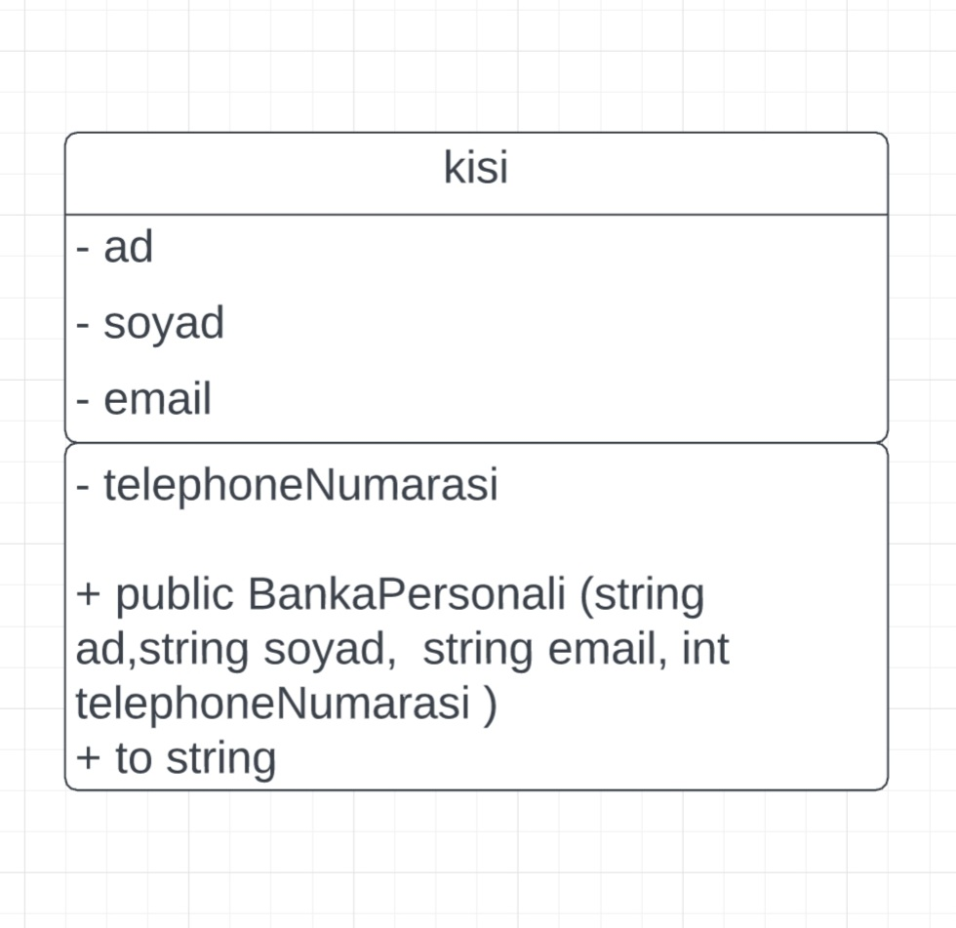

**Description:**

In the person class, there are common features that bank personnel and customers can have.   
  
The figure shows the properties that this class can have. The BankStaff and Customer classes inherit from the Person class. The properties that must be present in the BankPersonnel class are shown in the figure. In this class, create an ArrayList named customers to store the customers represented by the bank staff. Relevant customer objects will be stored in this ArrayList, design accordingly.should add to ArrayList. The delete account method should first check the balance of the account, if the account balance is greater than 0, it should display the warning "please transfer your balance to another account first". If it is equal to 0, delete the account. KrediKartiDelete method should first check the current debt information of the card, if it is equal to 0, it should delete the card, otherwise "please pay the debt first".

